RGB LED Control System with LCD Menu
Aditya Maindargi | Manufacturing Science & Engineering
COEP Technological University

Overview
This project is an interactive RGB LED control system built using an Arduino UNO, I2C LCD display, potentiometer, push button, and RGB LED.
The system allows the user to navigate between different color options using a potentiometer. The currently selected color is displayed on the LCD screen with a menu-style selector (>). Pressing the button turns ON the selected LED color, while releasing the button turns the LED OFF.
The entire project was:
- Designed logically from scratch
- Simulated in Tinkercad
- Physically wired and tested
- Documented and uploaded to GitHub

Features
- Interactive LCD menu system
- RGB LED color selection
- Potentiometer-based navigation
- Push-button controlled output
- I2C LCD communication
- Modular function-based programming
- Real-time hardware interaction

Components Used
- Arduino UNO
- 16x2 I2C LCD Display
- RGB LED
- Potentiometer
- Push Button
- Resistors
- Breadboard
- Jumper Wires

Circuit Connections

RGB LED Connections
RGB LED Pin | Arduino Pin
Red | D11
Green | D10
Blue | D9

Potentiometer Connections
Potentiometer Pin | Connection
Left Pin | 5V
Middle Pin | A0
Right Pin | GND

Push Button Connections
Button Pin | Connection
One Side | D8
Other Side | GND
Pull-down Resistor | Connected to GND

I2C LCD Connections
LCD Pin | Arduino UNO
GND | GND
VCC | 5V
SDA | A4
SCL | A5

Simulation Screenshots
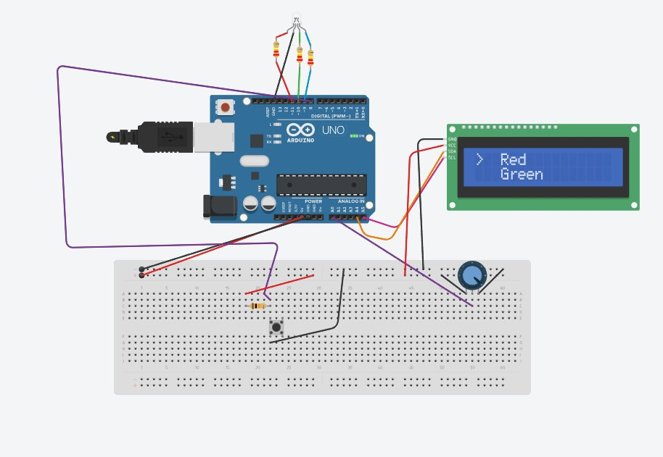
Image 1 - Red selected, cursor on row 1
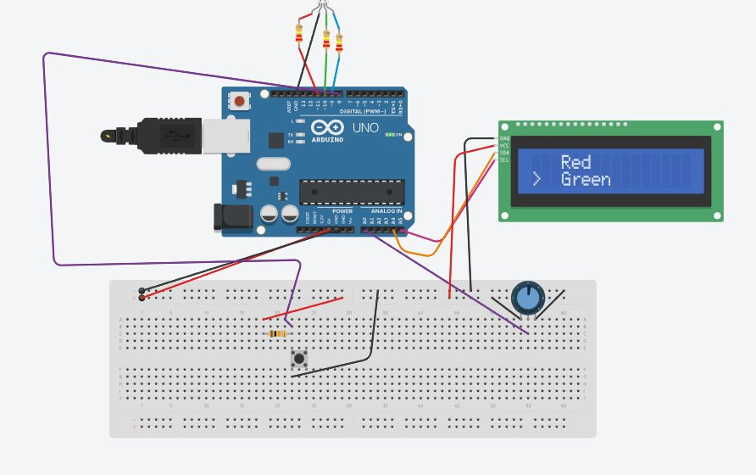
Image 2 - Red selected, cursor on row 2
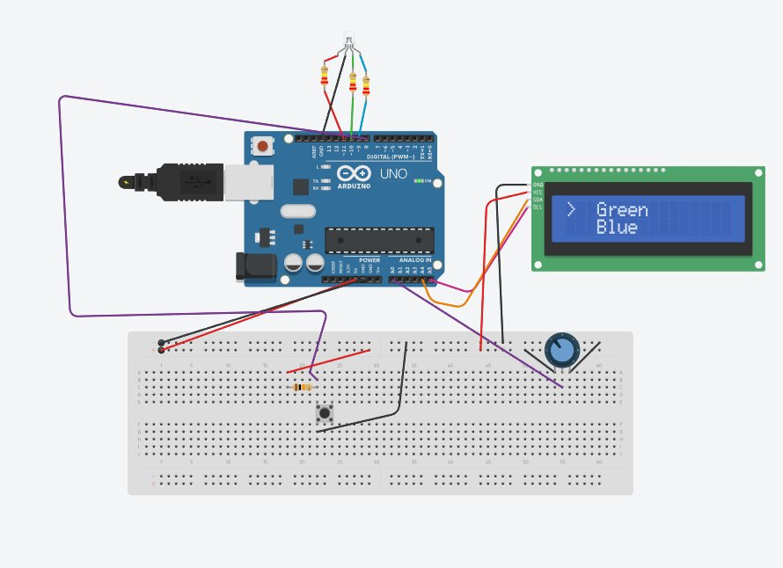
Image 3 - Green selected, Blue below
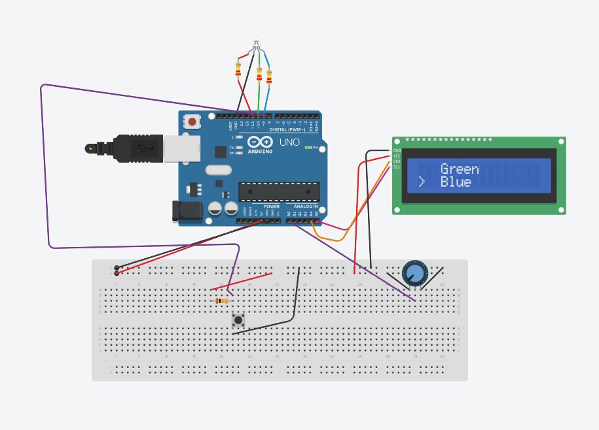
Image 4 - Green selected, Blue highlighted

Working Principle
- The potentiometer is used to navigate through color options.
- The LCD displays the current selection.
- A selector (>) indicates the active choice.
- When the push button is pressed: the selected RGB color turns ON.
- When the button is released: the RGB LED turns OFF.

LCD Menu Logic
The menu dynamically changes based on potentiometer values:
- Red selected
- Green selected
- Blue selected
The LCD updates in real-time according to analog input.

Source Code
#include <Wire.h>
#include <LiquidCrystal_I2C.h>
LiquidCrystal_I2C lcd(0x27, 16, 2);
int Pot = A0;
int PotVal;
int Red = 11;
int Green = 10;
int Blue = 9;
int button = 8;
int button_input;
String Color[] = {"Red", "Green", "Blue"};
void red() {
digitalWrite(Red, HIGH);
digitalWrite(Green, LOW);
digitalWrite(Blue, LOW);
}
void green() {
digitalWrite(Red, LOW);
digitalWrite(Green, HIGH);
digitalWrite(Blue, LOW);
}
void blue() {
digitalWrite(Red, LOW);
digitalWrite(Green, LOW);
digitalWrite(Blue, HIGH);
}
void Light() {
if (PotVal <= 330) { red(); }
else if (PotVal <= 679) { green(); }
else { blue(); }
}
void Light_off(){
digitalWrite(Red, LOW);
digitalWrite(Green, LOW);
digitalWrite(Blue, LOW);
}
void setup() {
pinMode(Red, OUTPUT);
pinMode(Green, OUTPUT);
pinMode(Blue, OUTPUT);
pinMode(Pot, INPUT);
pinMode(button, INPUT);
Serial.begin(9600);
lcd.init();
lcd.backlight();
}
void loop() {
PotVal = analogRead(Pot);
button_input = digitalRead(button);
Serial.println(PotVal);
lcd.clear();
if (PotVal <= 330) {
lcd.setCursor(0, 0); lcd.print(">");
lcd.setCursor(3, 0); lcd.print(Color[0]);
lcd.setCursor(3, 1); lcd.print(Color[1]);
} else if (PotVal <= 580) {
lcd.setCursor(0, 1); lcd.print(">");
lcd.setCursor(3, 0); lcd.print(Color[0]);
lcd.setCursor(3, 1); lcd.print(Color[1]);
} else if (PotVal <= 680) {
lcd.setCursor(0, 0); lcd.print(">");
lcd.setCursor(3, 0); lcd.print(Color[1]);
lcd.setCursor(3, 1); lcd.print(Color[2]);
} else {
lcd.setCursor(3, 0); lcd.print(Color[1]);
lcd.setCursor(0, 1); lcd.print(">");
lcd.setCursor(3, 1); lcd.print(Color[2]);
}
if (button_input == 0) { Light(); }
else if (button_input == 1) { Light_off(); }
delay(150);
}

Technologies Used
- Arduino IDE
- Embedded C/C++
- Tinkercad Simulation
- I2C Communication
- PWM Digital Outputs

Learning Outcomes
This project helped in understanding:
- Analog input handling
- Digital output control
- LCD interfacing using I2C
- Embedded systems logic
- Function-based code structuring
- Hardware simulation and debugging
- Circuit documentation

Future Improvements
- RGB brightness control using PWM
- Rotary encoder navigation
- EEPROM memory saving
- Multiple LCD menu pages
- Bluetooth/WiFi control using ESP32
- RTOS-based task handling
- Sensor integration

Project Status
- Simulation Completed
- Hardware Tested
- Fully Functional
- GitHub Uploaded
- Self-Designed Logic

Author
Aditya Maindargi
Manufacturing Science & Engineering
COEP Technological University

